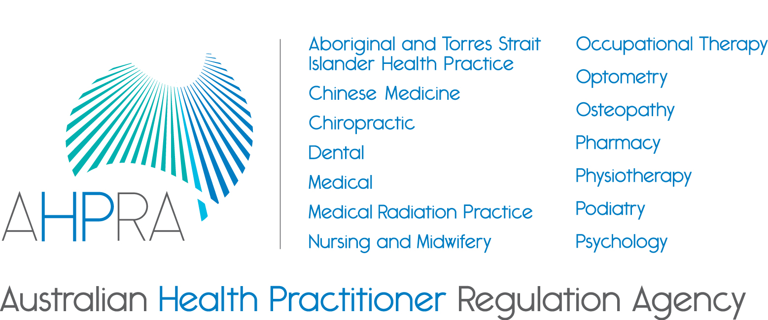

Application guide

August 2017
Community Reference Group
Guide for community members
This information package includes:
- information about the role of the Community Reference Group
- selection criteria
- selection process
- sitting fees and remuneration information, if application is successful, and
- relevant sections of the National Law.

Please also refer to the attached documents:
- application form
- declaration of private interests, and
- national criminal history check consent form.

Information for potential candidates
Introduction
The Australian Health Practitioner Regulation Agency (AHPRA) seeks applications from suitably qualified and experienced community members interested in being included on the AHPRA Community Reference Group (CRG).
The CRG performs an important advisory role to complement the functions of community members appointed to National Boards under the Health Practitioner Regulation National Law, as in force in each state and territory (the National Law), in protecting the Australian community.
What is involved?

Functions of the CRG include providing:
- information and advice on strategies for building community knowledge and understanding of the role of AHPRA and the National Boards in protecting the community and managing professional standards
- information and advice to AHPRA and the National Boards on strategies for consulting the community about issues relevant to their work
- feedback and advice from a consumer and community perspective on National Board standards, codes, guidelines, policies, publications and other specific issues, as requested by National Boards, and
- consumer and community perspectives and advice to the National Boards and AHPRA about issues relevant to the National Scheme.
The CRG will have an advisory role to the CEO of AHPRA. The advice of the CRG will be provided for information to the Agency Management Committee, National Boards and AHPRA’s National Executive. National Boards and AHPRA may choose to seek advice from the CRG through its Secretariat.
Appointments may be for up to three years, with eligibility for reappointment. Successful candidates will be appointed by the CRG Steering Committee, who governs the operation of the Community Reference Group. Applications will be assessed by a selection advisory panel and are expected to commence on 1 April 2018.
The CRG meets approximately four times per year at the AHPRA National Office in Melbourne for a full day meeting. On occasion, additional teleconferences may be convened as necessary.
The Community Reference Group Terms of Reference are available on the AHPRA website.
AHPRA
AHPRA supports the National Boards in managing the registration and notifications for health practitioners and students across Australia. AHPRA has a national office based in Melbourne and offices in every state and territory to support local boards and committees.
National Boards
The following 14 National Boards regulate the corresponding health professions under the National Law:
- Aboriginal and Torres Strait Islander Health Practice Board of Australia
- Chinese Medicine Board of Australia
- Chiropractic Board of Australia
- Dental Board of Australia
- Medical Board of Australia
- Medical Radiation Practice Board of Australia
- Nursing and Midwifery Board of Australia
- Occupational Therapy Board of Australia
- Optometry Board of Australia
- Osteopathy Board of Australia
- Pharmacy Board of Australia
- Physiotherapy Board of Australia
- Podiatry Board of Australia
- Psychology Board of Australia
Selection criteria
In selecting candidates for appointment to the CRG, the following attributes will be taken into account:
- Displays integrity: is ethical, committed, diligent, prepared, organised, professional, principles-based and respectful, values diversity, and shows courage and independence.
- Thinks critically: is objective and impartial, uses logical and analytical processes, distils the core of complex issues and weighs up options.
- Applies expertise: actively applies relevant knowledge, skills and experience to contribute to decision-making.
- Communicates constructively: is articulate, persuasive and diplomatic, is self-aware and reflects on personal impact and effectiveness, listens and responds constructively to contributions from others.
- Focuses strategically: takes a broad perspective, can see the big picture, and considers long term impacts.
- Collaborates in the interests of consumers and members of the community: is a team player, flexible and cooperative.
- Demonstrates experience: as a consumer or community advisory committee member.
- Is active and engaged: as a consumer or community advisor or advocate, beyond one organisation, cause or interest group.
Selection process
Applications will be assessed by the CRG Steering Committee. The CRG Steering Committee governs the activities of the CRG. The CRG Steering Committee comprises AHPRA executives, National Board community members and a National Board Chair as CRG Steering Committee Chair.

Applicants will be required to provide proof of identity and, if shortlisted, may undergo probity checks, which include:
- a national criminal history check by CrimTrac
- an Australian Securities and Investments Commission disqualification register check, and
- a National Personal Insolvency Index check conducted through the Australian Financial Security Authority.
Applicants are also required to provide information about whether they are current members of other government or statutory bodies.
Shortlisted candidates may be interviewed to ensure that they have the necessary qualifications, skills and experience for the position.
Referee reports
Referee reports are an important part of the selection process and at least one report will be obtained for all shortlisted applicants. Applicants are asked to nominate two to three referees who can support the application relevant to the key selection criteria and duties of the position.
Persons ineligible for appointment
Please note, the following persons are ineligible for appointment:
- anyone who has served as a member on an AHPRA National Board, panel or committee
- anyone who has been involved in any official capacity in the National Registration and Accreditation Scheme, or
- a currently registered health practitioner.
Sitting fees
Remuneration
Sitting fees are determined by the Australian Health Workforce Ministerial Council having regard to the remuneration generally applied to regulatory bodies with a substantial influence on the health industry.
The current remuneration (daily sitting fee) is detailed in the table below. The full day rate applies to all meetings or hearings and other assignments in excess of four hours in a day. The fees paid are assessable under the Income Tax Assessment Act 1997.
Under the Superannuation Guarantee (Administration) Act 1992 members are eligible to receive contributions at 9.5% cent of total annual remuneration to a chosen superannuation fund, payable when you are paid more than $450 in fees in a calendar month.
Government or statutory employees
AHPRA recognises that government and statutory employees may be bound by their employer policy regarding payment for employment undertaken outside of the employer which may alter the way members are paid.
We recommend applicants consult with their employer prior to applying to ensure an acknowledgement of permission can be provided from their employer, allowing them to be appointed as a member, and/or receive remuneration, should they be successful.
Expenses
Members are entitled to claim travel, accommodation and subsistence expenses incurred as part of their role. More information on allowances and the process of payments and claims will be provided if you are appointed.
Remuneration for Health Panels and Professional Standards Panels

Role | Attendance  (Fee includes preparation and up to 4 hours travel time) | Extra travel time
Role | Daily sitting fee  (more than 4 hours in a day) | Between 4-8 hours | Over 8 hours
Member | $642 | $321 | $642

For meetings that are less than 4 hours, half the daily fee is payable.

